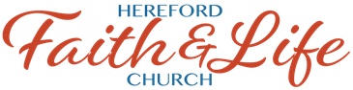
SAFE SANCTUARY CHILD WORKER ACKNOWLEDGEMENT FORM
- I have read and understand and agree to abide by the Safe Sanctuary Policy of Hereford Faith & Life Church.
- I have submitted my name and personally identifying information to the church office for a background check
- I agree with the following Statement of Faith and will not teach anything that directly contradicts or questions it.

Apostles' Creed
United Methodist Hymnal
I believe in God, the Father Almighty,
maker of heaven and earth;
And in Jesus Christ his only Son, our Lord;
who was conceived by the Holy Spirit,
born of the Virgin Mary,
suffered under Pontius Pilate,
was crucified, dead, and buried;*
the third day he rose from the dead;
he ascended into heaven,
and sits at the right hand of God the Father Almighty;
from thence he shall come to judge the quick and the dead.
I believe in the Holy Spirit,
the holy catholic** church,
the communion of saints,
the forgiveness of sins,
the resurrection of the body,
and the life everlasting. Amen.
*Traditional use of this creed includes these words: "He descended into hell."
**universal

Signature: ____________________________________________________________ Date: __________

Name (printed): _____________________________________________________ Cell #:_____________

